EX NO:16 ONLINE INTERNSHIP REGISTRATION

USE CASE DIAGRAM:

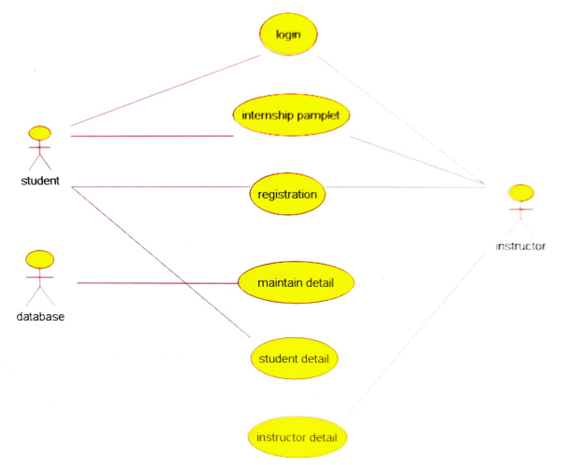

CLASS DIAGRAM:

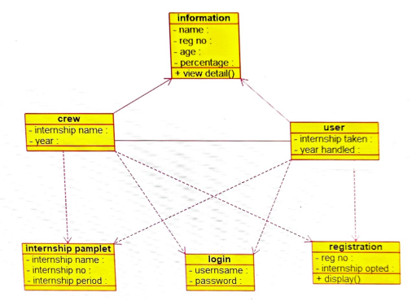

ACTIVITY DIAGRAM:

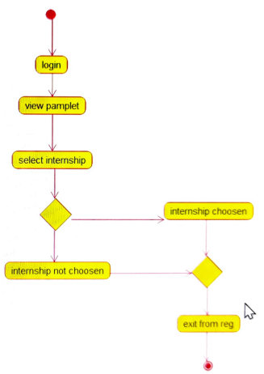

SEQUENCE DIAGRAM:

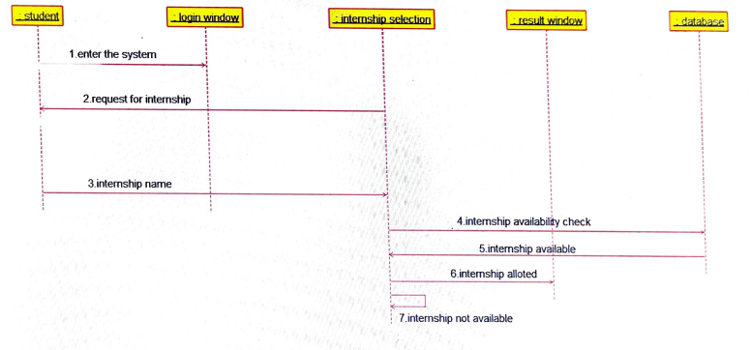

COLLABRATION DIAGRAM:

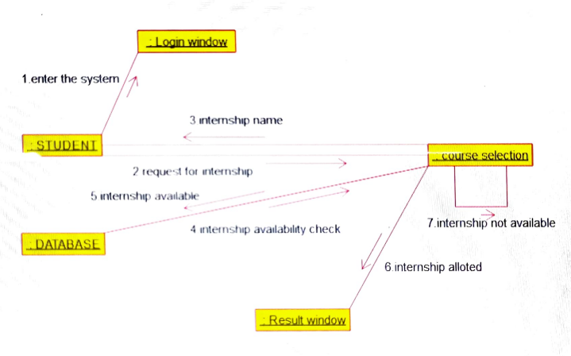

STATE CHART DIAGRAM:

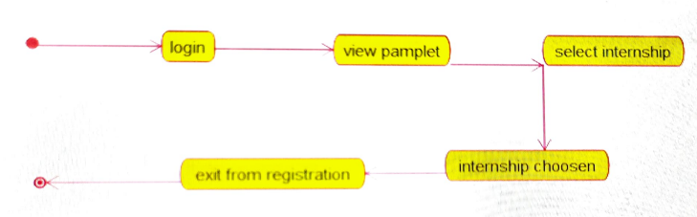

COMPONENT DIAGRAM:

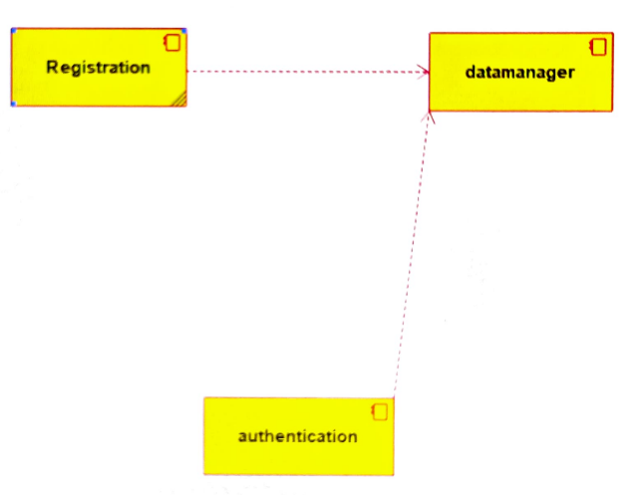

DEPLOYMENT DIAGRAM:

